The Dawson Group: Cheat sheet
Author: Frazer N. Forrester
Edited by:
This document is by no means a complete guide. It aims to provide tips and tricks that the author and subsequent collaborators have found useful in their endeavours.

The Unix Shell

Figure 1 shows an example file structure for a typical Linux operating system.
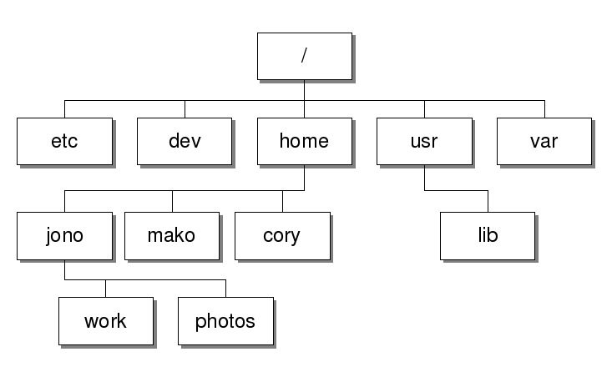
Figure 1. Unix Directory Architecture
A ‘PATH’ is the route taken from directory A to directory B. For example, to move from the ‘root’ directory to sub-directory ‘photos’ the following command PATH would be used:
cd home/jono/photos

Basic Linux commands

- cd {directory or PATH you want to go to} # Change directory
- pwd # print working directory (prints the PATH to the directory you are in)
- . #current directory
- .. #directory above current
- mv #moves directory (also used to rename a directory)
- cp #copy
- rm #remove (CAREFUL NO 2ND CHNACE!!! )
- mkdir {file_name} #Make directory
- clear #clears terminal (scroll up and it will all still be there)
- ls # lists contents of a directory
- cat {file_name} #displays contents of file
- less {file_name} #view file but not edit
- chmod #Allocates executability and readability permissions of a file.

Wildcards:

Wildcards allow you to find multiple items with similar names and find files when you can only partly remember their names (A frequent occurrence unfortunately!)
- * #wildcard character- matches zero or more characters in a filename
- *[AB] #use wildcard with square brackets says it could match A or B
- ? #wildcard character – Matches any single character

Pipes and filters
- wc #word count command- counts no. of lines word and characters in a file (L to R)
- sort #alphanumerical sort
- > #points output into a file (overwrites file if it already exists)
- >> #appends file if it already exists
- echo #prints strings
- head #gives line from start of a file
- tail #gives line from end of a file
- | #A pipe makes output of one command the input of another
- cut #cuts out certain sections of each line in a file (expects sections to be separated by tab)
- uniq #filters out adjacent matching lines

Use of flags

Flags are used to specify a commands operation. Use:
{your_command} --help
To find which flags are available and their purpose.

Examples for using flags:

cp -r {Directory}
#The flag here stands for ‘recursive’, allowing the directory and its contents to be copied.
sort -n #sorts in ascending numerical order
head -n 3 {file_name} #gives first 3 lines of a file

High Power computing (Rocket, Archer etc)

Rocket:
Campus access:
- ssh {username}@rocket.hpc.ncl.ac.uk #Accessing rocket
Remote access:
- ssh {username}@unix.ncl.ac.uk
- ssh {username}@rocket.hpc.ncl.ac.uk
Useful commands:
- squeue -u {username} #view queued jobs
- sacct #Displays active jobs
- cd /nobackup/proj/jditise #Navigates from home directory to group project folder

Version Control git and git hub

Use in this order:
- git init #makes the directory git accessible
- git add #notifies git of changes
- git commit -m #commits the changes to git
others:
- git log #shows users previous git actions
- git log -1 #shows most recent lo entry only (change the number to go up the history)
- git log –oneline #puts log on one line

Git Hub
- git remote add origin https://github.com/fforrester/... # assigns git directory a repository
- git remote -v #tells us where we can pull and push from
- git push origin master #pushes committed work to git hub repository assigned
- git pull origin master #pulls anything new updates from remote repository to the directory.
Note: Use of the word ‘master’ soon to be replaced with ‘main’

Useful Links
#Software carpentries (Unix shell, git and python)
https://pad.carpentries.org/2020-12-07-NCL-SWC-ONLINE

Extra notes
When using windows subsystem i.e. Ubuntu and can’t access H drive use:
Sudo mkdir /mnt/h #makes directory for h drive to be located
Sudo mount -t drvfs H: /mnt/h #mounts the H drive in the directory created

